Phase 2
Team: Delta4 | Spring 2026

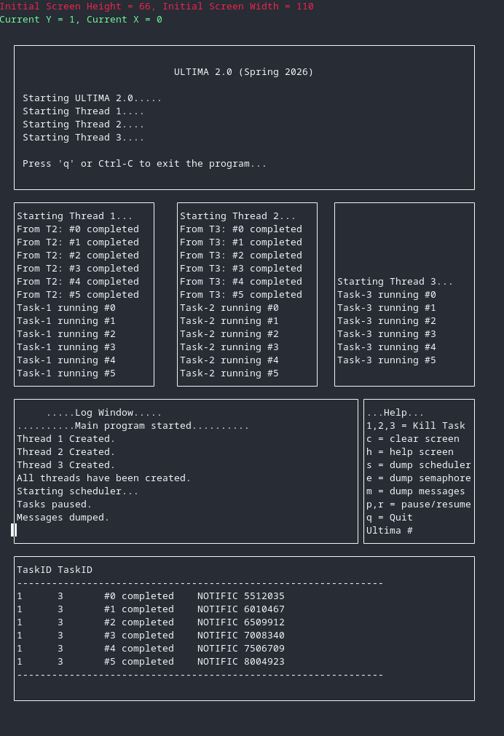
Ultima Interface
The Ultima interface has been updated so that while each task is running, they send messages to another task. Then, each task reads its message queue an displays them in their window.
In this screenshot, execution has been paused while task #1 is running. In the bottom window, you can see all the messages currently enqueued, with task #1 having send 6 messages to task #3.

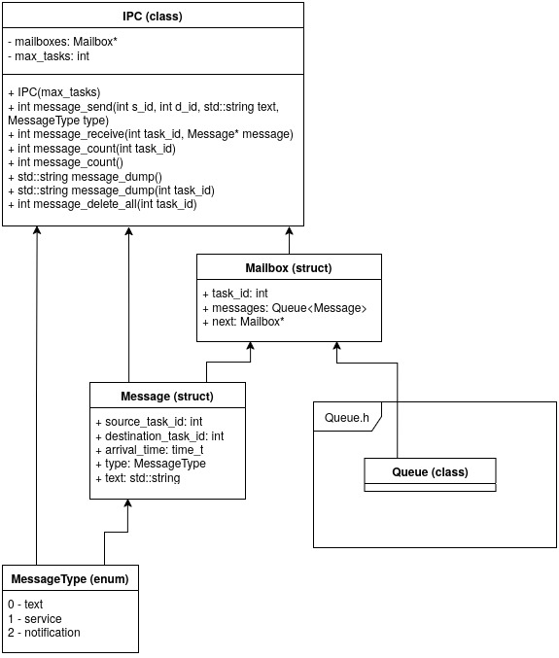
Code
This diagram shows how the classes are structured. The IPC class stores a linked list of mailboxes, and each mailbox stores a queue of messages.

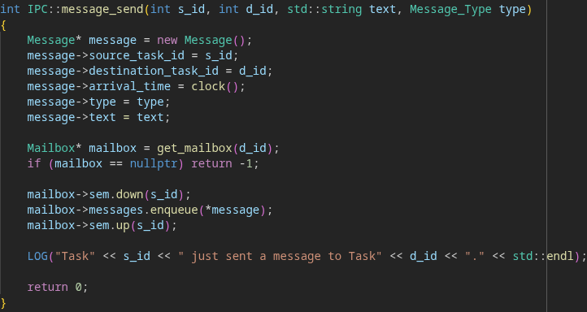
These are the function definitions for message_send and message_receive, where a semaphore is used to protect the mailbox whenever it is modified.

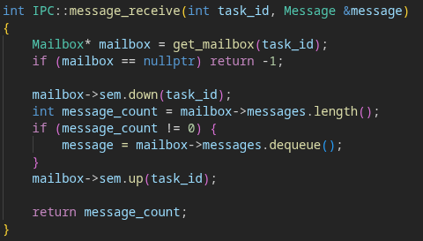

Testing
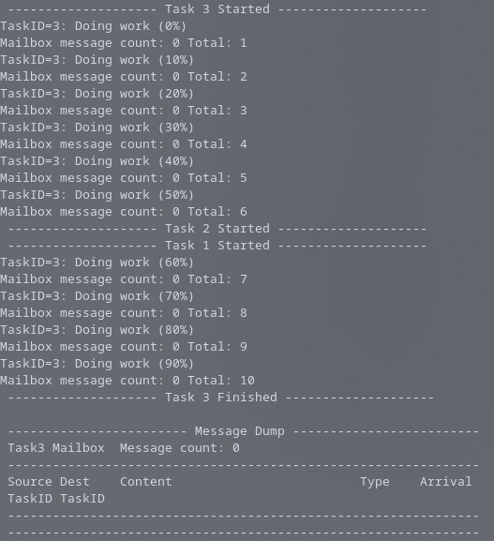
Starting out, task #3 obtains the resource via the semaphore, blocking the execution of tasks #1 and #2.
Whenever it “does work”, it sends a message to task #2. You can see when it completes, task #3 doesn’t have any messages in its queue.

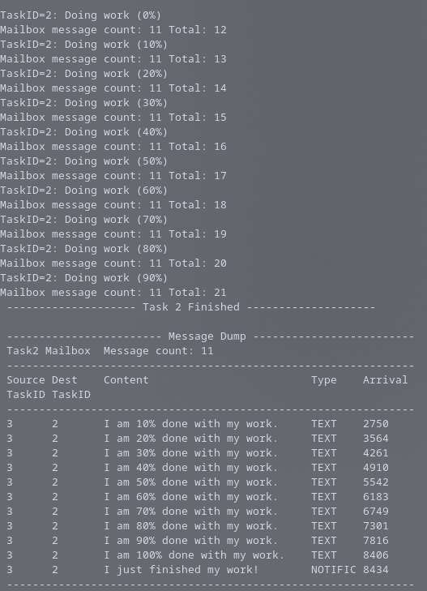
Next, task #2 obtains the resource and begins running. When it finishes executing (and sending messages to task #1), you can see its message queue is full of messages from task #3.

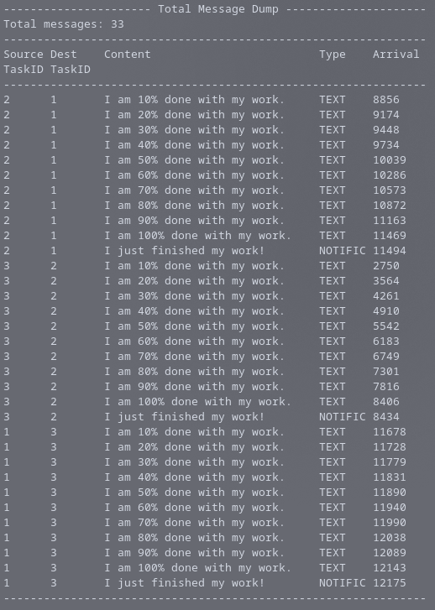
Once all tasks have executed, the total message dump shows the messages sent between the tasks.

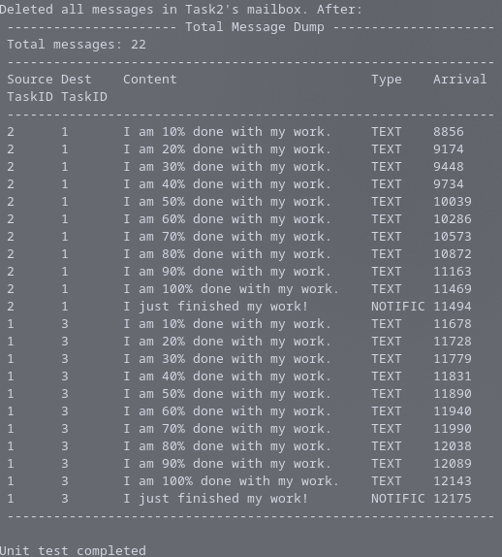
Finally, all messages for task #2 are removed, leaving only messages for tasks #1 and #3 in the queue.

